PIZZA SALES SQL QUERIES
1.Total revenue:
select SUM(total_price) as total_revenue from pizza_sales;
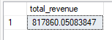
2.Total pizza sold
select SUM(quantity) as Total_pizza_sold from pizza_sales;
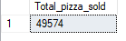
3. Average order value

select SUM(total_price) / COUNT(DISTINCT order_id) as avg_ord_val from pizza_sales;
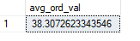
4.total order
select count(DISTINCT order_id) as total_order from pizza_sales;
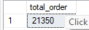

5. avg_pizza_per_order
select cast(sum(quantity) as decimal (12,2))/cast(count(distinct order_id) as decimal (12 , 2)) as avg_pizza_per_order from pizza_sales;
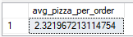
6.daily trend for total order
select DATENAME(DW , order_date) as Days ,sum(distinct order_id) as Total_revenue
from pizza_sales
group by DATENAME(DW , order_date);
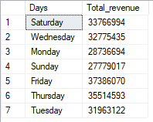

7.monthly trend for total order
select DATENAME(MONTH , order_date) as months ,sum(distinct order_id) as total_revenue
from pizza_sales
group by DATENAME(MONTH , order_date);
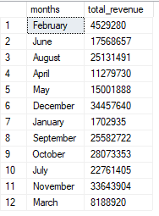
8.percentage of sales by pizza category
select pizza_category , sum(total_price) as total_price , sum(total_price)*100 / (select sum(total_price) from pizza_sales) as per_sales
from pizza_sales
group by pizza_category;

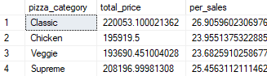
Note :if we want to filter based on month , week , quarter then use where clause . for ex
select pizza_category , sum(total_price) as total_price , sum(total_price)*100 / (select sum(total_price) from pizza_sales) as per_sales
from pizza_sales
where MONTH (order_date) = 4 # 4 means April data
group by pizza_category;
above code shows only percentage of April month out off all the month
select pizza_category , sum(total_price) as total_price , sum(total_price)*100 / (select sum(total_price) from pizza_sales where MONTH (order_date) = 4) as per_sales
from pizza_sales
where MONTH (order_date) = 4
group by pizza_category;
above code shows percentage of April month

also we can round off percentage using cast
select pizza_category , cast(sum(total_price) as decimal(12,2)) as total_price , cast(sum(total_price)*100 /(select sum(total_price) from pizza_sales where MONTH (order_date) = 4) as decimal (12 , 2)) as per_sales
from pizza_sales
where MONTH (order_date) = 4
group by pizza_category;

9. % of Sales by Pizza Size
select pizza_size , sum(total_price) *100 / (select sum(total_price) from pizza_sales) as percentg
from pizza_sales
group by pizza_size;
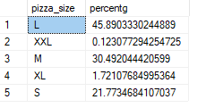
10. Total Pizzas Sold by Pizza Category

select pizza_category ,sum(quantity) as Total_quantity
from pizza_sales
group by pizza_category
order by Total_quantity DESC;

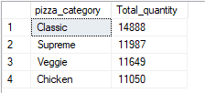

11.top 5 pizza by revenue
select TOP 5 pizza_name , sum(total_price) as total_revenue
from pizza_sales
group by pizza_name
order by total_revenue desc;
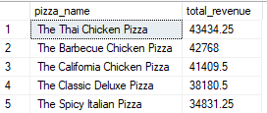

12.top 5 pizza by quantity
select top 5 pizza_name , sum(quantity) as Total_quantity
from pizza_sales
group by pizza_name
order by Total_quantity DESC;
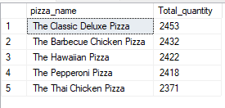

13.top 5 pizza by total_order

select top 5 pizza_name , count(distinct order_id) as total_order
from pizza_sales
group by pizza_name
order by total_order desc;

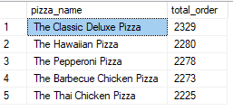
12.Bottom 5 pizza by revenue
select top 5 pizza_name , sum(total_price) as total_price
from pizza_sales
group by pizza_name
order by total_price ASC;
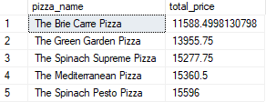
13.Bottom 5 pizza by quantity
select top 5 pizza_name , sum(quantity) as total_quantity
from pizza_sales
group by pizza_name
order by total_quantity ASC;
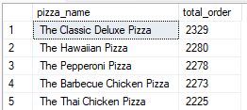

14.Botom 5 pizza by total_order

select top 5 pizza_name , count(distinct order_id) as total_order
from pizza_sales
group by pizza_name
order by total_order ASC;
